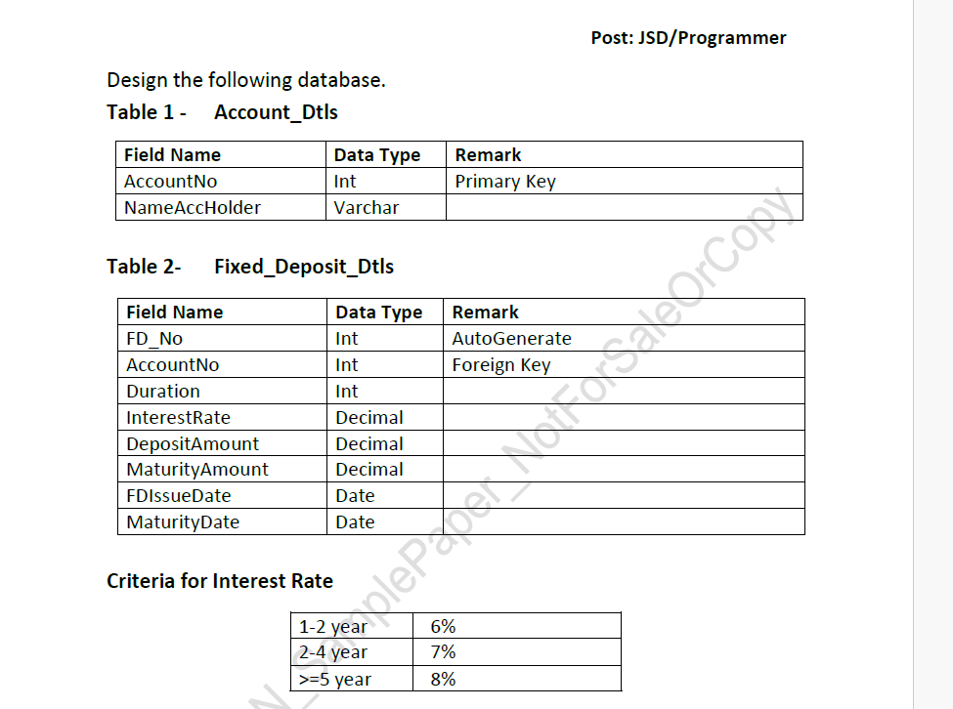

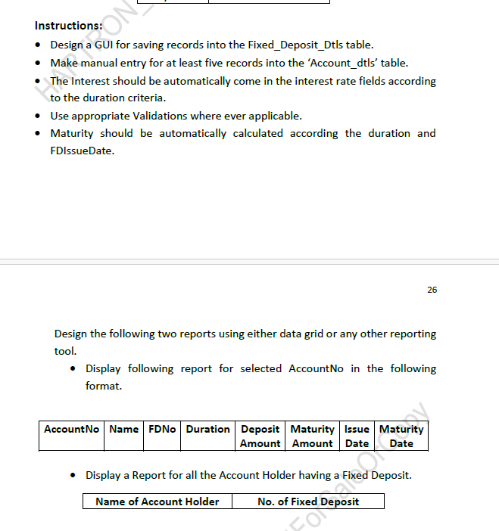

Model

using System;
using System.Collections.Generic;
using System.ComponentModel.DataAnnotations;
using System.Linq;
using System.Web;

namespace Account.Models
{
public class AccountModel
{
[Display(Name = "Account Holder Name")]
public int AccountNo { get; set; }

[Display(Name = "Duration")]
public int Duration { get; set; }

[Display(Name = "Interest Rate")]
public decimal InterestRate { get; set; }

[Display(Name = "Deposite Amount")]
public decimal DepositeAmount { get; set; }

[Display(Name = "Maturity Amount")]
public decimal MaturityAmount { get; set; }
[Display(Name = "FD Issue Date")]
public DateTime FDIssueDate { get; set; }
[Display(Name = "Maturity Date")]
public DateTime MaturityDate { get; set; }

}
}

Controller
using Account.Models;
using System;
using System.Collections.Generic;
using System.Configuration;
using System.Data;
using System.Data.SqlClient;
using System.Linq;
using System.Web;
using System.Web.Mvc;

namespace Account.Controllers
{
public class HomeController : Controller
{
decimal interest;
public ActionResult Index()
{
var account = getaccountno();

ViewBag.account = new SelectList(account.AsDataView(), "AccountNo", "NameAccHolder");

return View();
}

[HttpPost]
public ActionResult Index(AccountModel obj)
{
string cnn = ConfigurationManager.ConnectionStrings["cn"].ConnectionString;
SqlConnection con = new SqlConnection(cnn);
decimal InterestRate;
int Duration = obj.Duration;
DateTime MaturityDate = DateTime.Now.AddYears(Duration);
decimal DepositAmount = obj.DepositeAmount;

if (Duration >=1 && Duration <=2)
{
interest = 6;
}

else if (Duration >=3 && Duration <= 4)
{
interest = 7;
}

else if(Duration >=5)
{
interest = 8;
}

InterestRate = DepositAmount * interest / 100;
Decimal MaturityAmount = DepositAmount + InterestRate;

string query = "insert into Fixed_Deposit_Dtls values (@AccountNo, @Duration, @InterestRate, @DepositeAmount, @MaturityAmount, @FDIssueDate, @MaturityDate)";
SqlCommand cmd = new SqlCommand(query, con);
cmd.Parameters.Add("@AccountNo", SqlDbType.Int).Value = obj.AccountNo;
cmd.Parameters.Add("@Duration", SqlDbType.Int).Value = obj.Duration;
cmd.Parameters.Add("@InterestRate", SqlDbType.Decimal).Value = InterestRate;
cmd.Parameters.Add("@DepositeAmount", SqlDbType.Decimal).Value = obj.DepositeAmount;
cmd.Parameters.Add("@MaturityAmount", SqlDbType.Decimal).Value = MaturityAmount;
cmd.Parameters.Add("@FDIssueDate", SqlDbType.DateTime).Value = obj.FDIssueDate;
cmd.Parameters.Add("@MaturityDate", SqlDbType.DateTime).Value = MaturityDate;
con.Open();
cmd.ExecuteNonQuery();
con.Close();
ViewBag.Message = "Record Saved Successfully";

var account = getaccountno();

ViewBag.account = new SelectList(account.AsDataView(), "AccountNo", "NameAccHolder");
ViewBag.interest = InterestRate;
ViewBag.maturity = MaturityDate;
ViewBag.maturitya = MaturityAmount;
return View();
}

public DataTable getaccountno()
{
string cnn = ConfigurationManager.ConnectionStrings["cn"].ConnectionString;
SqlConnection con = new SqlConnection(cnn);
SqlDataAdapter adb = new SqlDataAdapter("Select * from Account_Dtls", con);
DataTable dt = new DataTable();
adb.Fill(dt);
return dt;

}

public ActionResult Report1()
{
string cnn = ConfigurationManager.ConnectionStrings["cn"].ConnectionString;
string query = @"select row_number() over (order by ad.AccountNo) as [Sr. No.], ad.AccountNo as [Account No.], ad.NameAccHolder as [Account Holder Name], fd.FD_No as [FD No.], fd.Duration as [Duration], sum(fd.DepositeAmount) as [Deposit Amount], sum(fd.MaturityAmount) as [Maturity Amount], fd.FDIssueDate as [FD Issue Date], fd.MaturityDate as [Maturity Date] from Fixed_Deposit_Dtls fd inner join Account_Dtls ad on ad.AccountNo = fd.AccountNo group by ad.AccountNo, ad.NameAccHolder, fd.FD_No, fd.Duration, fd.FDIssueDate, fd.MaturityDate";
SqlDataAdapter adb = new SqlDataAdapter(query, cnn);
DataTable dt = new DataTable();
adb.Fill(dt);
ViewBag.ResultTable = dt;
return View();
}

public ActionResult Report2()
{
string cnn = ConfigurationManager.ConnectionStrings["cn"].ConnectionString;
string query = @"select ROW_NUMBER() over (order by ad.NameAccHolder) as [Sr. No.], ad.NameAccHolder as [Name of Account Holder], count(fd.FD_No) as [No. of Fixed Deposit] from Fixed_Deposit_Dtls fd inner join Account_Dtls ad on ad.AccountNo = fd.AccountNo group by ad.NameAccHolder";
SqlDataAdapter adb = new SqlDataAdapter(query, cnn);
DataTable dt = new DataTable();
adb.Fill(dt);
ViewBag.ResultTable = dt;
return View();
}
public ActionResult About()
{
ViewBag.Message = "Your application description page.";

return View();
}

public ActionResult Contact()
{
ViewBag.Message = "Your contact page.";

return View();
}
}
}

Index
@model Account.Models.AccountModel

@{
ViewBag.Title = "Index";
}

<h2>Index</h2>

@using (Html.BeginForm())
{
@Html.AntiForgeryToken()

<div class="form-horizontal">
<h4>AccountModel</h4>
<hr />
@Html.ValidationSummary(true, "", new { @class = "text-danger" })
<div class="form-group">
@Html.LabelFor(model => model.AccountNo, htmlAttributes: new { @class = "control-label col-md-2" })
<div class="col-md-10">
@Html.DropDownListFor(model => model.AccountNo, (SelectList)ViewBag.account, "---Select Account Holder Name.---", new { @class = "form-control" })
@Html.ValidationMessageFor(model => model.AccountNo, "", new { @class = "text-danger" })
</div>
</div>

<div class="form-group">
@Html.LabelFor(model => model.Duration, htmlAttributes: new { @class = "control-label col-md-2" })
<div class="col-md-10">
@Html.EditorFor(model => model.Duration, new { htmlAttributes = new { @class = "form-control" } })
@Html.ValidationMessageFor(model => model.Duration, "", new { @class = "text-danger" })
</div>
</div>

<div class="form-group">
@Html.LabelFor(model => model.DepositeAmount, htmlAttributes: new { @class = "control-label col-md-2" })
<div class="col-md-10">
@Html.EditorFor(model => model.DepositeAmount, new { htmlAttributes = new { @class = "form-control" } })
@Html.ValidationMessageFor(model => model.DepositeAmount, "", new { @class = "text-danger" })
</div>
</div>

<div class="form-group">
@Html.LabelFor(model => model.FDIssueDate, htmlAttributes: new { @class = "control-label col-md-2" })
<div class="col-md-10">
@Html.EditorFor(model => model.FDIssueDate, new { htmlAttributes = new { @class = "form-control", type = "Date" } })
@Html.ValidationMessageFor(model => model.FDIssueDate, "", new { @class = "text-danger" })
</div>
</div>

<div class="form-group">
<div class="col-md-offset-2 col-md-10">
<input type="submit" value="Save Record" class="btn btn-success" />
</div>
</div>
</div>
}
<br />
@ViewBag.Message
<br />
The Interest is : @ViewBag.interest
<br />
The Maturity Amount is : @ViewBag.maturitya
<br />
The Maturity Date is : @ViewBag.maturity

<div>
@Html.ActionLink("Back to List", "Index")
</div>

@section Scripts {
@Scripts.Render("~/bundles/jqueryval")
}

Report1
@{
var dt = ViewBag.ResultTable as System.Data.DataTable;
}

<table class="table table-bordered table-striped table-hover text-center">

<tr>
<th>Sr. No.</th>
<th>Account No.</th>
<th>Account Holder Name</th>
<th>FD No.</th>
<th>Duration</th>
<th>Deposit Amount</th>
<th>Maturity Amount</th>
<th>FD Issue Date</th>
<th>Maturity Date</th>
</tr>

@if (dt != null)
{
foreach (System.Data.DataRow row in dt.Rows)

{
<tr>
<td>@row["Sr. No."]</td>
<td>@row["Account No."]</td>
<td>@row["Account Holder Name"]</td>
<td>@row["FD No."]</td>
<td>@row["Duration"]</td>
<td>@row["Deposit Amount"]</td>
<td>@row["Maturity Amount"]</td>
<td>@row["FD Issue Date"]</td>
<td>@row["Maturity Date"]</td>
</tr>

}

}

</table>

Report2

@{
var dt = ViewBag.ResultTable as System.Data.DataTable;
}

<table class="table table-bordered table-striped table-hover text-center">

<tr>
<th>Sr. No.</th>
<th>Name of Account Holder</th>
<th>No. of Fixed Deposit</th>
</tr>

@if (dt != null)
{
foreach (System.Data.DataRow row in dt.Rows)

{
<tr>
<td>@row["Sr. No."]</td>
<td>@row["Name of Account Holder"]</td>
<td>@row["No. of Fixed Deposit"]</td>
</tr>

}

}

</table>

